VoteCounts

Table as per design

The Data type are the same

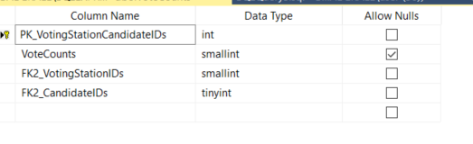

Rows retrieved 4968 rows

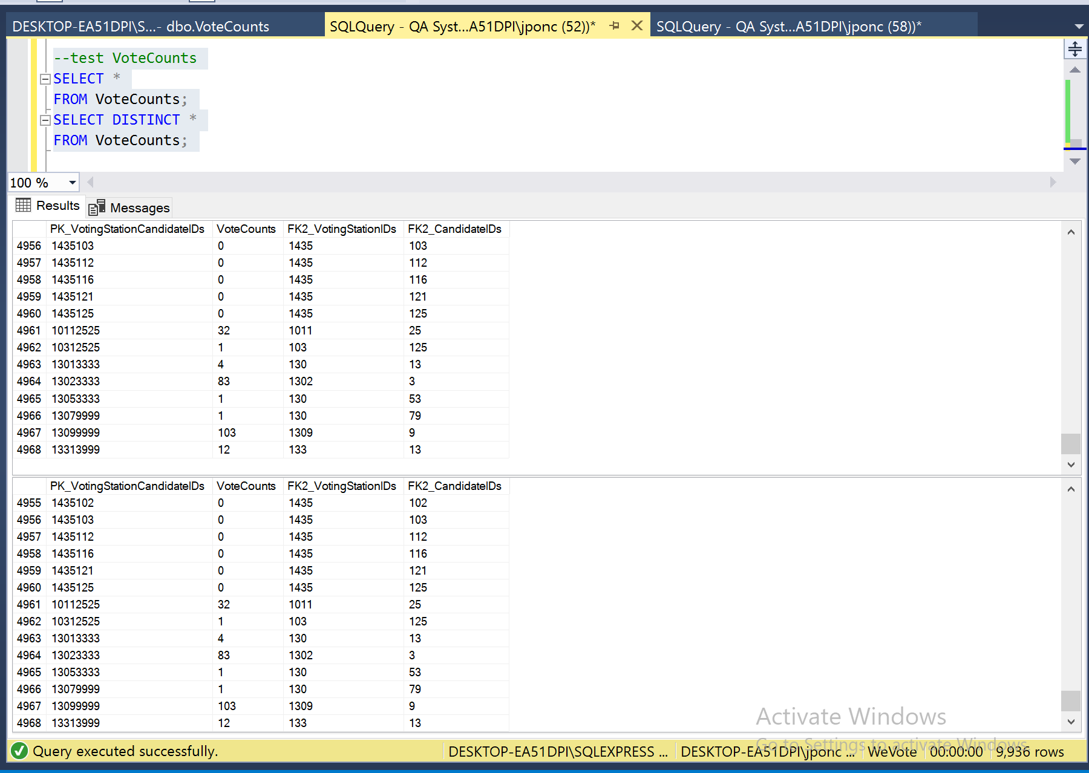

Data Manipulation

Primary Key not related to other table and with Foreign Key

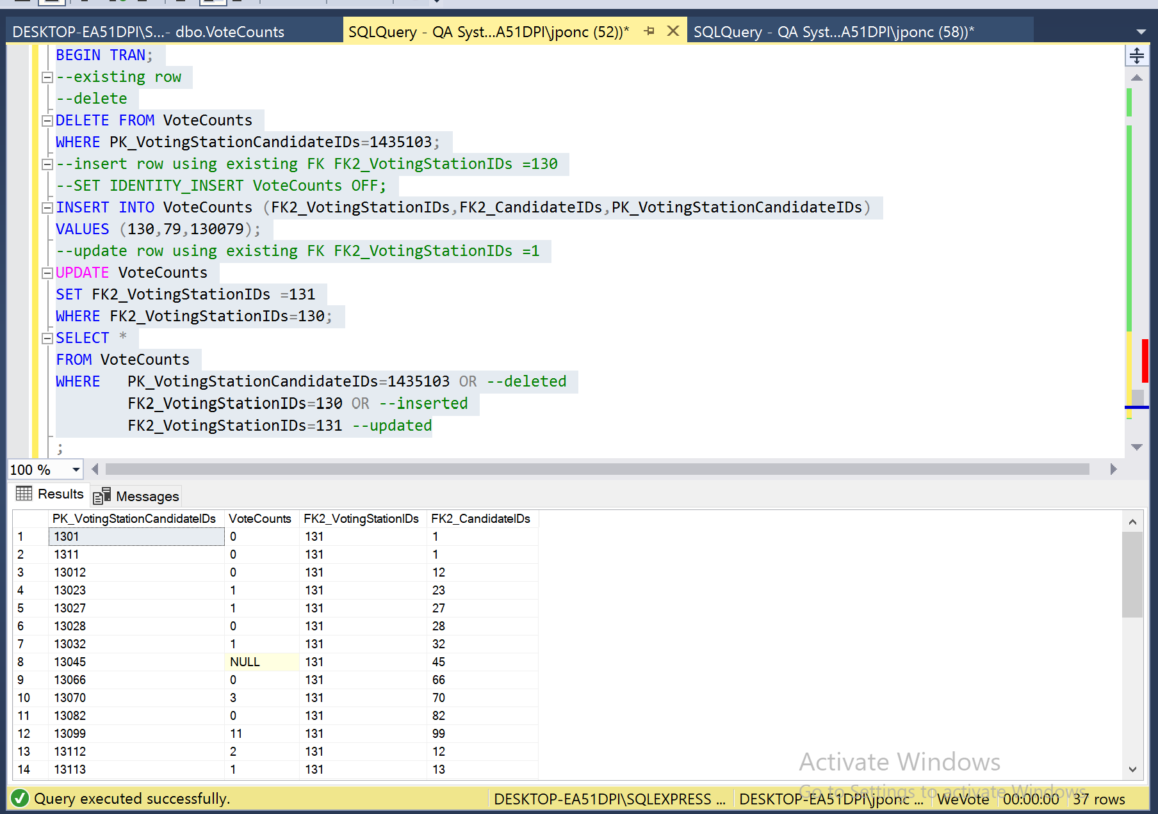

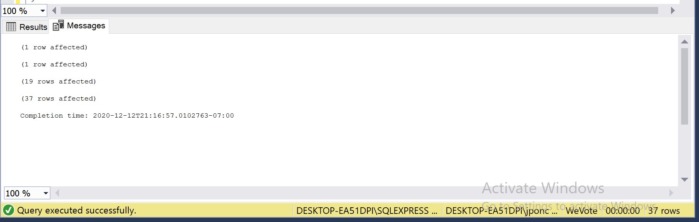

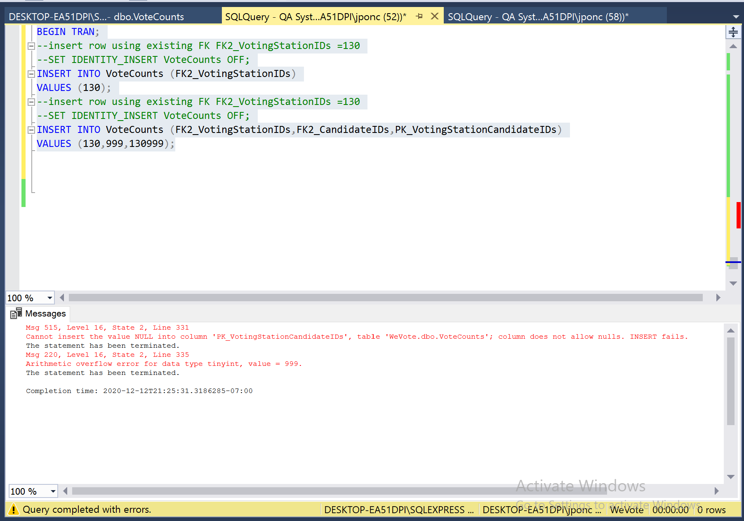

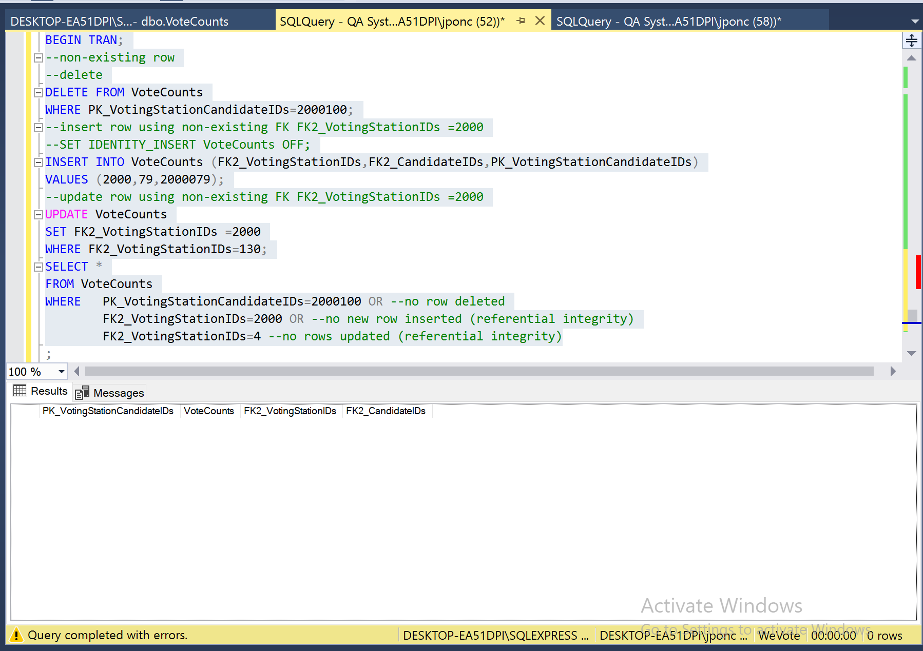

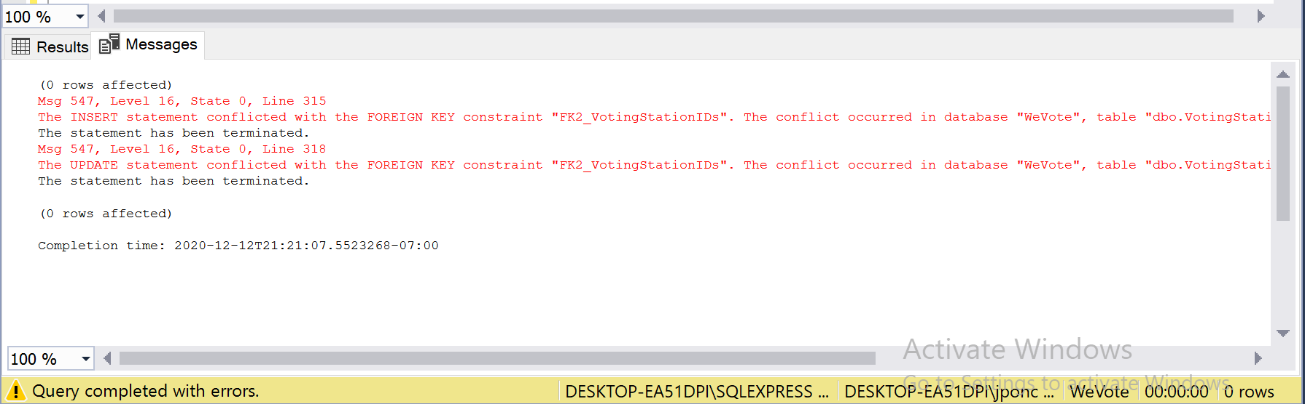

## For table VoteCount:

The fig below show the column that allow Nulls 

Executing

“ Begin Transaction insert into VoteCount(PK_VotingStationCandidateIDs)

Values('130')”

Error Cannot insert the value NULL into column 'FK2_VotingStationIDs', table 'WeVote.dbo.VoteCounts'; column does not allow nulls. INSERT fails. was generated because nulls are not allowed in FK2_CandidateIDs column

Executing

Begin Transaction

insert into VoteCounts(PK_VotingStationCandidateIDs,FK2_VotingStationIDs,FK2_CandidateIDs)

Values('130','106','2')

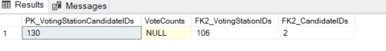

No error because nulls are allowed in VoteCounts column

# **VoteCount Table**

Constraint on VoteCount Table

CONSTRAINT [VoteCounts] CHECK (([VoteCounts]>=(0)))

**Execution**

Begin Transaction

insert into VoteCount(VoteCounts,FK2_VotingStationIDs,FK_CandidateIDs)

Values('-1','101','45')

Error The INSERT statement conflicted with the CHECK constraint "VoteCounts". The conflict occurred in database "WeVote", table "dbo.VoteCount", column 'VoteCounts'. is generated validating the constraint given